**WD-MAJOR-AUGUST-**[**WD-08-MLB1**](https://classroom.google.com/u/0/c/NTQ4NTEzNjQ1MDI3)

**BY: - ABHAY RAJ**

1. **The project is made by Abhay Raj, Email - abhayraj2002@hotamil.com of August Batch of Web Development Batch.**
2. **The links for the GitHub project are: -** [**GITHUB CODE LINK**](https://github.com/rajabhay1803/WD-MAJOR-AUGUST-WD-08-MLB1.git)
3. **The link of the hosted site is: -**[**WEBSITE LINK**](https://rajabhay1803.github.io/WD-MAJOR-AUGUST-WD-08-MLB1/)

**SCREENSHOT OF THE PAGE: -**

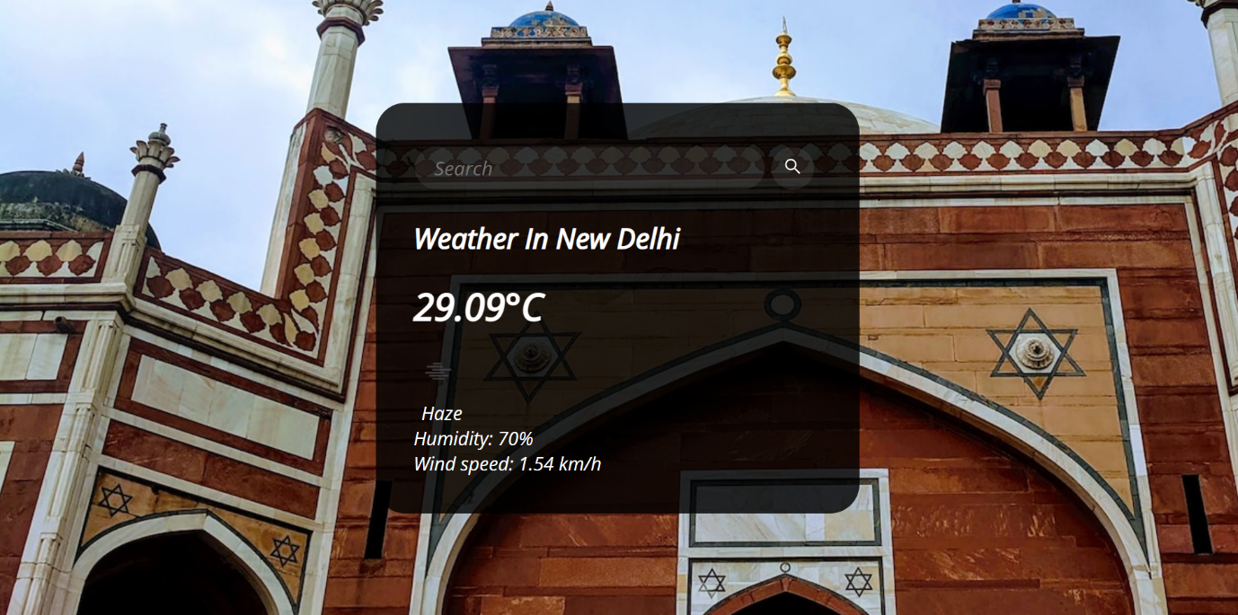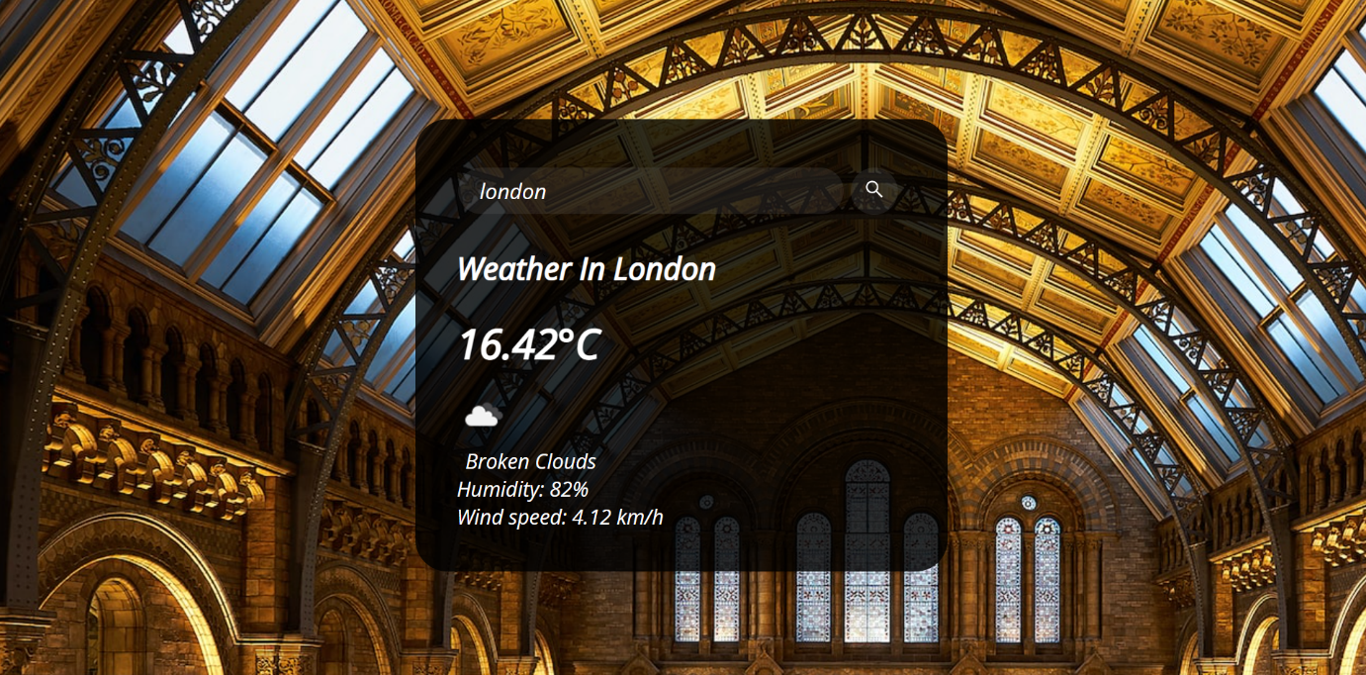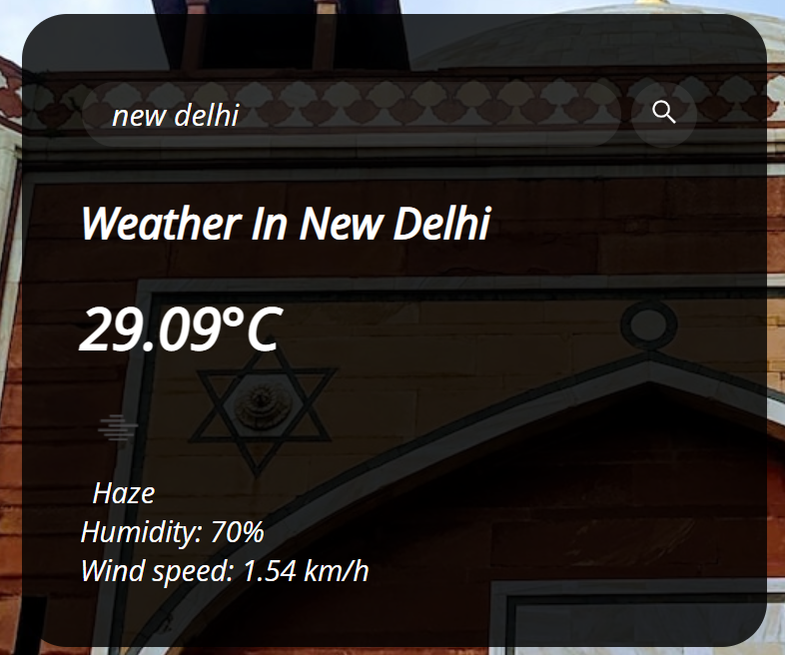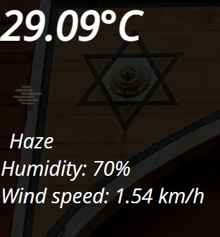

**THE SCREEN SHOT FOR THE PAGE AND CODE USED IN MAKING THE PAGE: -**

1. **HTML CODE: -**

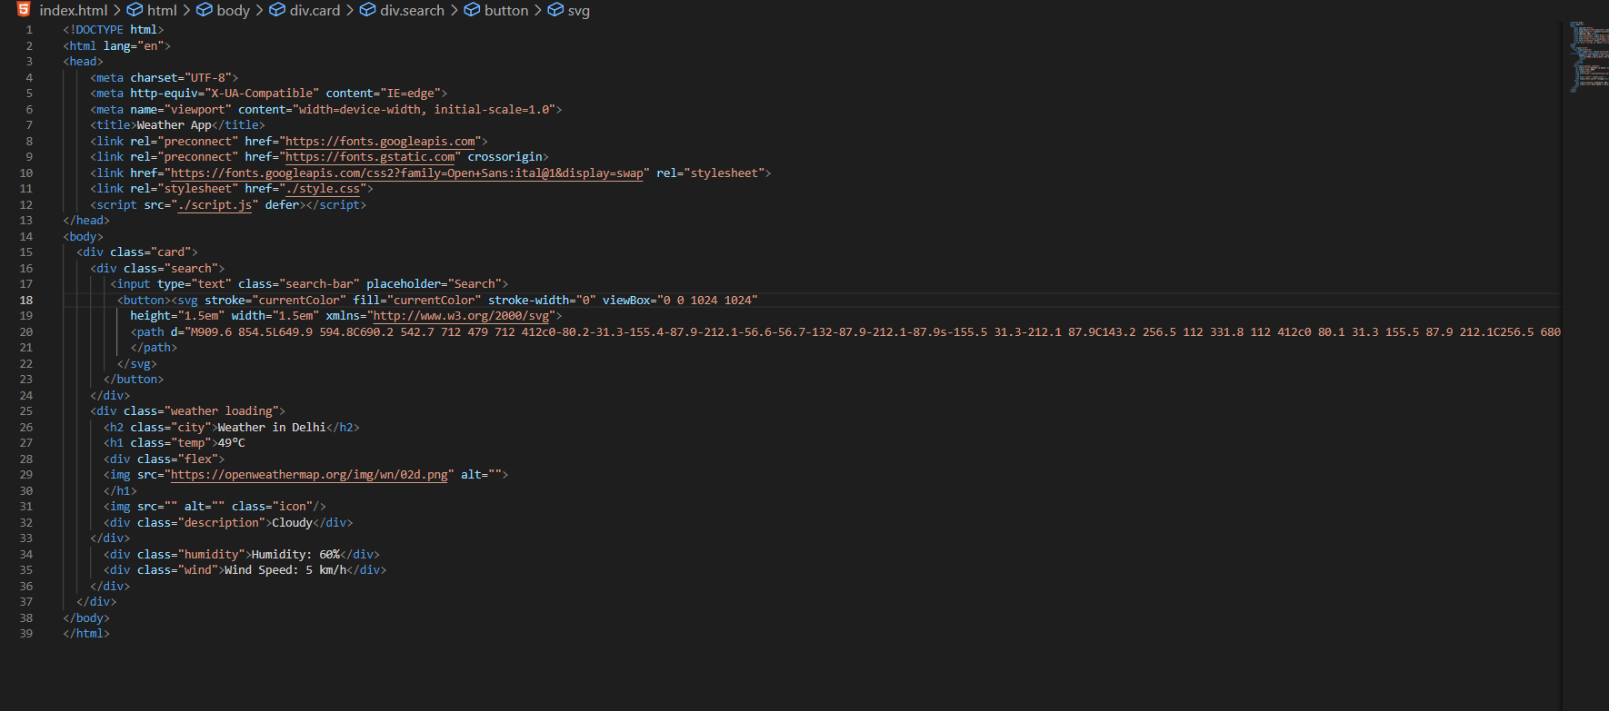

1. **CSS CODE: -**

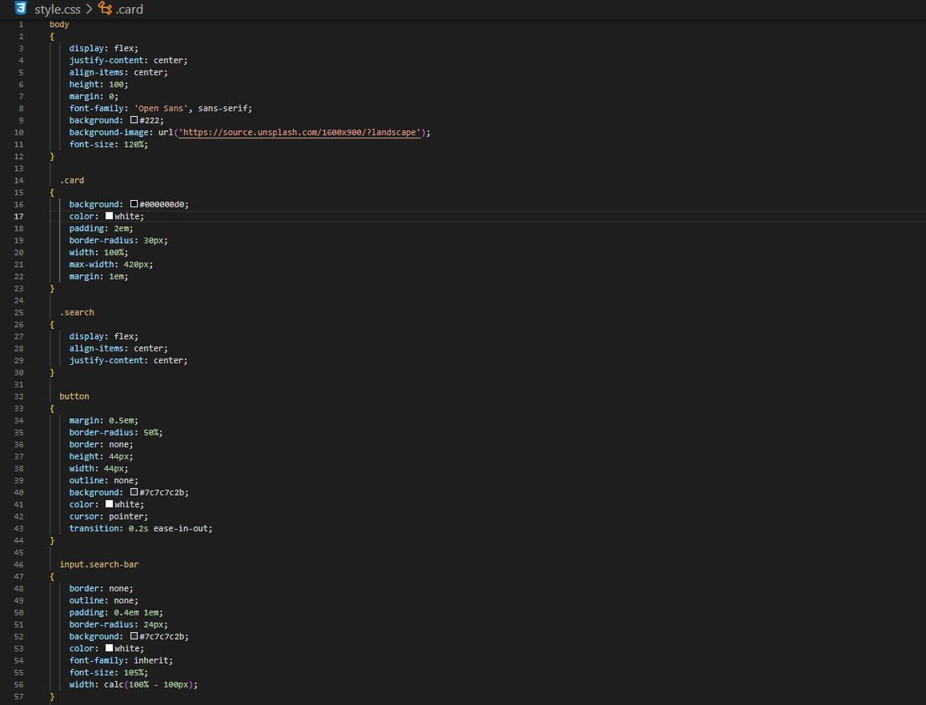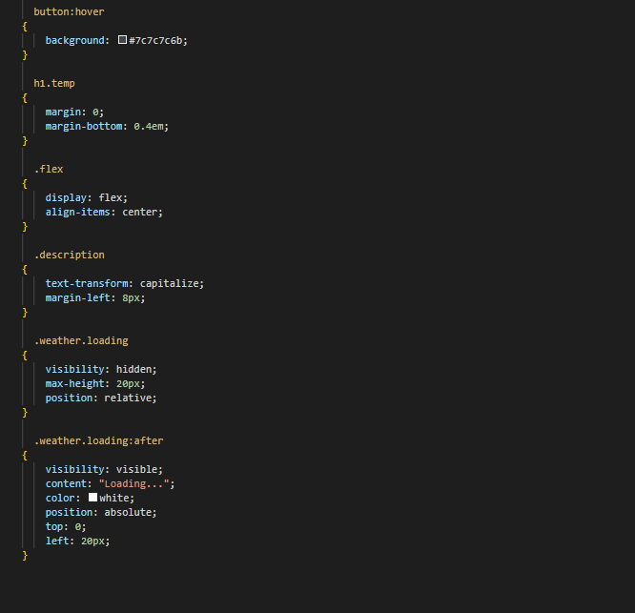

1. **JAVASCRIPT CODE: -**

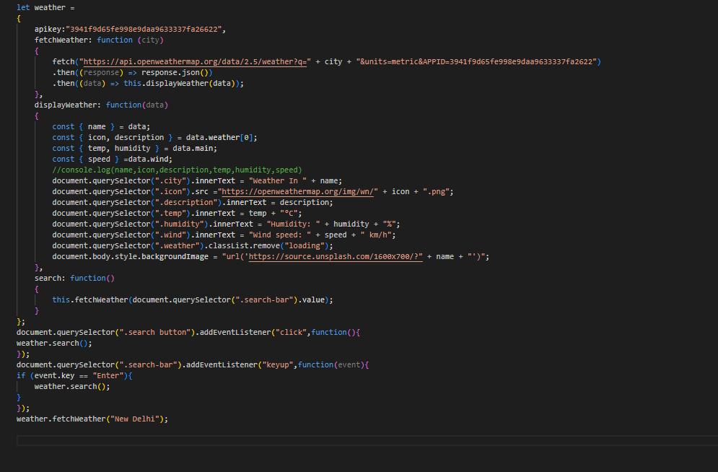

**FUNCTIONALITY OF THE CODE: -**

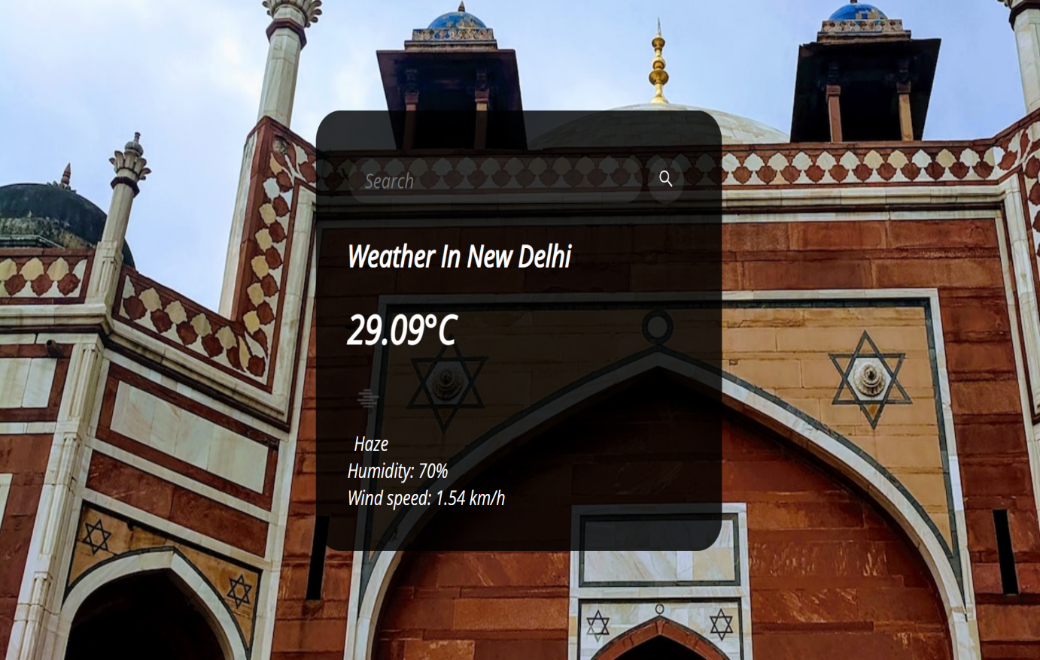



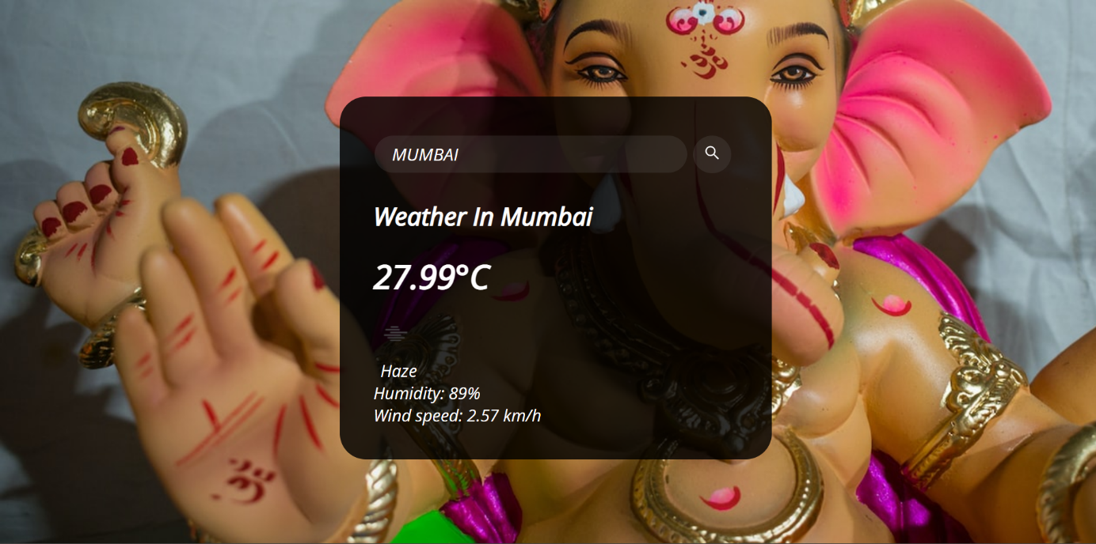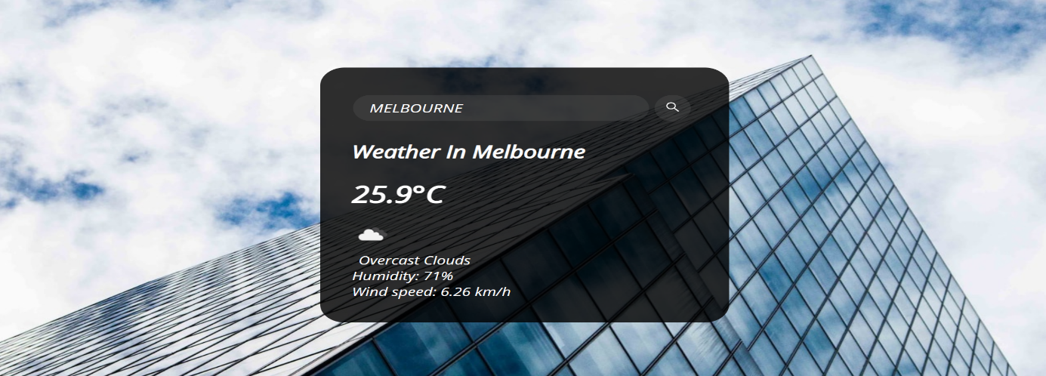

**THANK YOU**

**BY: - ABHAY RAJ**